CYBER BULLING DETECTION

AN INTERNSHIP PROJECT REPORT

By
KANDA ROOPADEVI
323103210099
Under the Esteemed Guidance of
Mrs. D. Indu
Assistant Professor
CSE Department

Department of Computer Science and Engineering
GAYATRI VIDYA PARISHAD COLLEGE OF ENGINEERING FOR WOMEN
[Approved by AICTE NEW DELHI, Affiliated to AU, Visakhapatnam]
[Accredited by National Board of Accreditation (NBA) for B.Tech. CSE, ECE & IT – Valid from 2019-22 and 2022-25] [Accredited by National Assessment and Accreditation Council (NAAC)– Valid from 2022-27] Kommadi , Madhurawada, Visakhapatnam–530048.

– 2025

GAYATRI VIDYA PARISHAD COLLEGE OF ENGINEERING FOR WOMEN

DEPARTMENT OF COMPUTER SCIENCE AND ENGINEERING

CERTIFICATE
This is to certify that the internship project report titled “Cyberbullying Detection” is the Bonafide work of the following B.Tech. students from the Department of Computer Science and Engineering, Gayatri Vidya Parishad College of Engineering for Women, affiliated with Andhra University, Visakhapatnam. The project was done during II Year 2 Semester and it is being evaluated in III Year – 1 Semester of the academic year 2025 - 2026.

KANDA ROOPADEVI
323103210099
Internal Guide / Mentor | Head of the department
Mrs. D. Indu. | Dr. P. V. S. Lakshmi Jagadamba
Assistant Professor | Professor

(EXTERNAL SIGN)

CERTIFICATE

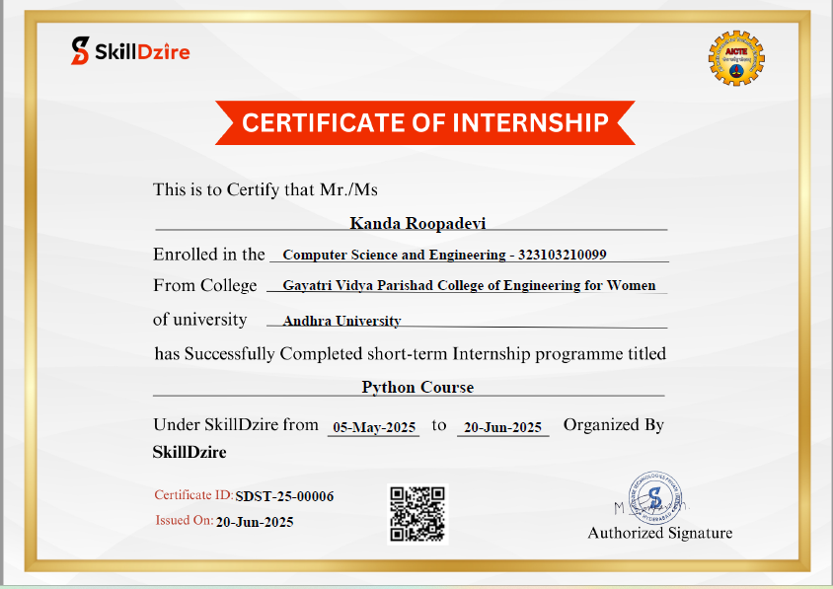

ACKNOWLEDGEMENT
The satisfaction that accompanies the successful completion of any task would be incomplete without the mention of people who made it possible and whose constant guidance and encouragement crown all the efforts with success.
I would like to take the opportunity to express my profound sense of gratitude to the revered Principal, Dr. R. K. Goswami for all the help and support towards the successful completion of my project.
I would like to take this opportunity to express my profound sense of gratitude to Vice Principal, Dr. G. Sudheer for allowing us to utilize the college resources there by facilitating the successful completion of our project. I am also thankful to both teaching and nonteaching faculty of the Department of Computer Science and Engineering for giving valuable suggestions for my project.
I express our deep sense of gratitude and thanks to Dr. P. V. S. Lakshmi Jagadamba, Professor and Head of the Department of Computer Science and Engineering for her guidance and for expressing her valuable and grateful opinions in the project for its development and for providing lab sessions and extra hours to complete the project
I feel elated to extend our sincere gratitude Mrs. D. Indu, Assistant Professor, and Mentor of my project for her encouragement all the way during analysis of the project. Her annotations, insinuations and criticisms are the key behind the successful completion of the thesis and for providing me with all the required facilities.
.

TABLE OF CONTENTS
 | TOPICS | PAGE NO.
 | Abstract | 1
1. | INTRODUCTION | 2
 | 1.1 Problem Statement | 2
 | 1.2 Main Aim | 2
 | 1.3 Objective | 3-4
2. | RELATED WORK | 5-6
3. | SYSTEM ANALYSIS | 7-8
 | 3.1 Introduction | 7
 | 3.2 Software Requirement Specification | 7
 | 3.3 System requirements | 8
 | 3.3.1 Minimum Software requirements | 8
 | 3.3.2 Minimum Hardware requirements | 8
4. | SYSTEM DESIGN | 9-11
 | 4.1 Introduction | 9
 | 4.2 UMLdiagrams | 9
 | 4.2.1 Use case diagram | 9
 | 4.2.2 Class diagram | 10
 | 4.2.3 Sequence diagram | 10
 | 4.2.4 Activity diagram | 11
5. | METHODOLOGY | 12-15
 | 5.1 Project Architecture Diagram | 12
 | 5.2 Key Components and Workflow | 12-13
 | 5.3 Modules and Descriptions | 13-15
6. | IMPLEMENTATION | 16-24
7. | OUTPUT SCREENS | 25-27
8. | TESTING | 28-29
 | 8.1 Introduction | 28
 | 8.2 Types of Testing | 28
 | 8.3 Test Cases | 29
 | 8.4 Conclusion of Testing | 29
9. | CONCLUSION | 30
10. | FUTURE SCOPE | 31
11. | REFERENCES | 32

